January, 2000

Dear fan
Over 200 members at the beginning of 2000! We thought this would be a good moment to bring some interesting statistics into picture about the personalities of the members the fan club counts so far:
- From where are you? (graphic 1)
The largest part of our members is from the USA, but next in line are Canada, The Netherlands and Belgium. That’s probably due to the impact of the site and its divisions being constructed in Dutch and English. Other countries well represented are England, Germany, Brazil and Sweden. But did you know we have members out of countries like Latvia, Lebanon, India, Malaysia, Mexico, South Africa, Vietnam, Iceland, … too?
- Average age of a Céline Dion Internet Fan Club member (graphic 2)
1 out of 3 members joining the Céline Dion Internet Fan Club is between 15 and 20. Most others are younger than 15 or aged between 20 and 25. There’s also a group of people aged 35 or more that currently seems to develop a growing interest for the Internet. Right now our youngest member is 12 and our eldest is 59.
- Most of you are female (graphic 3)
This is a remarkable fact. Regarded the knowledge Céline is a woman (and a beautiful one, if I dare say so), one would think the number of male fans would exceed (or at least equal) that of her female fans. Yet, it is the other way around. 70 % of all our members are women. Then they say the Internet is mainly a man’s world. I assure you, for Céline fans it isn’t! Maybe more guys will team up with us in 2000? They are certainly most welcome!
Even though Céline is taking a well-deserved break, we at CDIFC (and the other divisions) won’t let you down while you’re hungry to find out ever more. We will keep you busy with more letters each month and a great place called “Selected Info” at A Dutch/English Céline Dion Site where you can go to read all about the many topics we have yet to introduce there.
CD (see thee)
The Céline Dion Internet Fan Club*
- GRAPHIC 1

other 1 = Finland, France, Korea, Switzerland
other 2 = Austria, Denmark, Indonesia, Malaysia, Norway, Turkey
other 3 = Australia, China, Croatia, Iceland, India, Ireland, Israel, Japan, Latvia, Lebanon, Mexico, Philippines, Portugal, Scotland, Slovakia, Slovenia, South Africa, Spain, Trinidad, Vietnam

- GRAPHIC 2
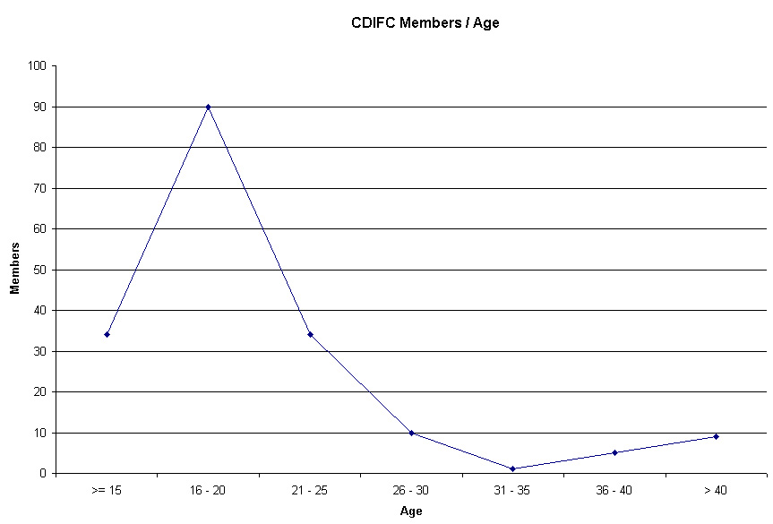

- GRAPHIC 3
